This is a note on the routing.py part of the model and not the path builder

This is just a explanation for when routes will need to be switched. This is to do with the route.py section where we had two different scenarios that would trigger a rerouting to occur. One was if there is a traffic build up and there is an opportunity to use an alternate route and second was if wind direction did not favour either an aircraft going for take-off or landing since the wind is directed in a way that would make such a manoeuvre dangerous so they would have to either wait till the wind changed direction to suit the manoeuvre since they cannot reverse and go back or if they are on their way to take-off and haven’t yet reached the point in their journey where they can only go down a single path (i.e reroute without reversing), they can reroute to the opposite side of the runway for take-off. For landing, rerouting wouldn’t need to occur, we would just spawn the aircraft at the opposite end of the runway.

Here are the two scenarios that would cause a route switch:
- For DEPARTURES:
  - GATETAXIWAYHOLD IN POINTQUEUEHOLD OUT POINTRUNWAYTAKE-OFF
- For ARRIVALS:
  - LANDINGRUNWAYHOLD IN POINTQUEUEHOLD OUT POINTTAXIWAYGATE

The image depicts what happens when windspeed and wind direction changes for aircrafts that have landed (ARRIVALS) or are going to take-off (DEPARTURE):

- ARRIVALS have two paths that they can take: RAPID or REGULAR since end taxiways can accommodate both DEPARTURES & ARRIVALS
- DEPARTURES only have 1 path since rapid taxiways are only for ARRIVALS
- Observe how the paths for ARRIVALS & DEPARTURES switch
- Aircrafts landing favours HEADWIND, avoids TAILWIND
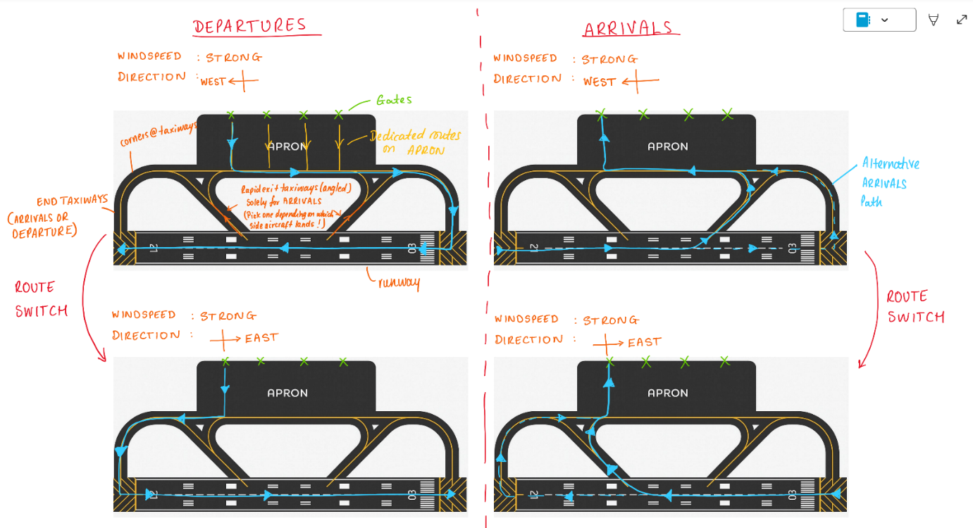
- Aircrafts taking-off favours TAILWIND, avoids HEADWIND
This is information on the path builder itself. The rules are a guide for how to implement and some of the requirements but I am open for discussion and clarification

PATH BUILDER - COMPLETE IMPLEMENTATION SPECIFICATION

OVERVIEW

The Path Builder is a simple 2D canvas tool for designing airport ground layouts as a basic graph of points and lines ONLY. It creates layout.json files containing pure geometry (positions, connections, angles, lengths) and airport section types (runway/taxiway/apron). Gates and hold positions are represented by points. Intersections are automatically detected where taxiway line paths cross each other. All paths use Bezier curves instead of sharp angles for smooth aircraft movement - whenever a line changes direction at a node, it automatically generates a smooth Bezier curve.

CANVAS SPECIFICATIONS
Canvas size is 3000m x 3000m representing a real airport area. Scale is 1px = 10m. Zoom range is 50% to 500% using mouse wheel (Shift + wheel to pan). Grid system toggles ON/OFF with presets: 10m (default), 15m, 25m, or Free. Angle snapping uses 15 degree increments from 0 to 180 degrees. Status bar shows scale, grid size, snap angle, node count, edge count, and intersection count.

TOOLBAR - 6 TOOLS (Simplified)
- Node Tool: Places points representing gates and hold positions. Click to place new node. Drag to move node. Right-click to delete.
- Straight Edge Tool: Draws paths between nodes. Click first node then second node to create path. Auto-snaps angles to 15 degree increments. Automatically converts sharp angle changes to smooth Bezier curves at nodes.
- Curved Edge Tool: Manually draws smooth Bezier curves between nodes. Click first node, drag control point, click second node. Provides fine control over curve shape.
- Tag Tool: Assigns airport section type only. Click element to set type: Runway / Taxiway / Apron.
- Erase Tool: Deletes selected node or edge. Shows confirmation dialog.
- Validate Tool: Checks geometry validity, pathway connectivity, and automatically detects intersections where taxiway paths cross.
ELEMENT TYPES (Pure Geometry with Smooth Curves)
Nodes (all appear as 8px black circles):
- Gate points: Manually placed aircraft parking positions
- Hold position points: Manually placed waiting positions before runway
- Intersections: Automatically detected where taxiway line paths cross each other (no manual placement)
Edges (all appear as smooth 2px Bezier curves):
- Runway: Smooth path section representing runway (Bezier curves at direction changes)
- Taxiway: Smooth path section representing taxiway (Bezier curves at direction changes, intersections auto-detected where taxiways cross)
- Apron: Smooth path section representing apron (Bezier curves at direction changes)

UI LAYOUT
Left panel shows 6 tool buttons. Center panel is the drawing canvas showing smooth Bezier curves. Right panel shows simple Type dropdown when element selected (Runway / Taxiway / Apron only). Bottom status bar shows current scale, grid, node/edge counts, intersection count, selected element length/angle.

PROPERTIES PANEL (Minimal)
When node selected:
- No properties (pure geometry point - gate or hold position)

When edge selected:
- Type dropdown: Runway / Taxiway / Apron only
- Shows length (meters) and average angle (degrees) as read-only info

AUTOMATIC BEZIER CURVE GENERATION
When multiple edges meet at a node and change direction:
- Detect incoming angle and outgoing angle at node
- Calculate control points using 30m radius curve (realistic taxiway turn radius)
- Generate smooth cubic Bezier curve: start_pos, control1, control2, end_pos
- Store control points in JSON for simulation playback
Straight Edge Tool automatically creates these curves at every direction change. Curved Edge Tool allows manual control point adjustment.

VALIDATION RULES (Three Categories)

1. ICAO GEOMETRY STANDARDS
PASS:
- All curves have minimum 120m radius (ICAO Code D/E taxiway standard)​
- Edge angles multiples of 15 degrees
- Edge lengths minimum 10m
FAIL:
- Any curve radius <120m (too sharp for jet aircraft - ICAO violation)​
- Edge angle not multiple of 15 degrees
- Edge length <10m

2. GEOMETRY VALIDITY
PASS:
- All nodes within canvas bounds
- No duplicate nodes
FAIL:
- Node outside bounds
- Duplicate node positions
- Invalid node connections

3. PATHWAY CONNECTIVITY
PASS:
- All edges connect valid nodes
- No floating nodes/edges
FAIL:
- Floating nodes (no connections)
- Floating edges (invalid node IDs)
- Disconnected sections

WORKFLOW
- File - New to start blank canvas
- Node tool to place gates and hold positions
- Straight Edge tool connects points with automatic 120m radius Bezier curves
- Curved Edge tool for manual curves (radius enforcement active)
- Tag tool sets section types
- Validate checks 120m minimum radius and all geometry
- File - Save creates ICAO-compliant layout.json

JSON contains positions, connections, lengths, angles, section types, auto-detected intersections, and Bezier control points.
KEYBOARD SHORTCUTS
Ctrl+N: New layout
Ctrl+O: Open layout
Ctrl+S: Save layout
Delete: Erase selected element
G: Toggle grid
V: Run validation
Escape: Deselect all
Tab: Next tool

